

EBAY CONTROLLER TEST DATA SHEET

P/N: N_A Date: 11/04/2018 Time: 16:15

S/N: N_A Tested by: ds

Hardware Rev: BLDC_60A_V6 Approved by: ds

Software Rev: N_A

Tester Software Version: 1.2j

Equipments Used

Equipments Model No Serial No

Power Supply

Digital Multimeter

CAN Interface

BLDC Tester

PC

Heater

RS-232 Interface

Current Meter

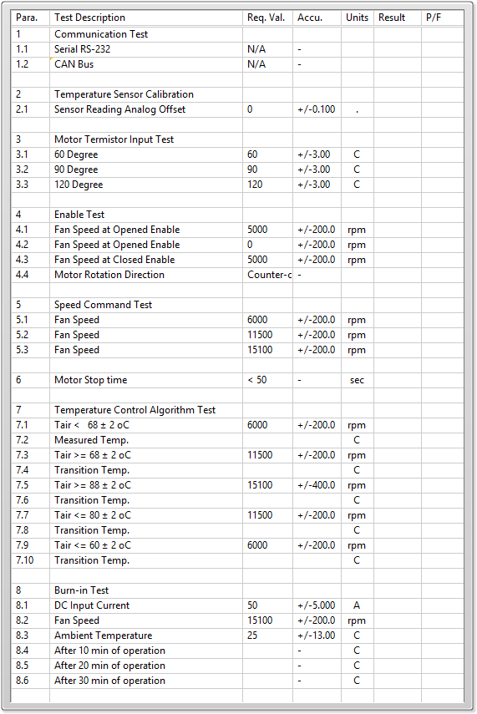

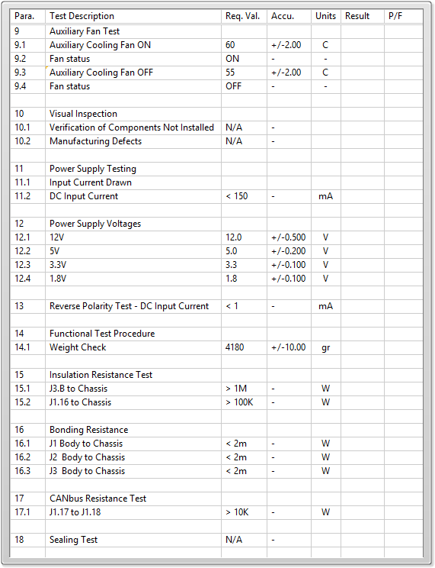

General result:

Test-Operator:____ ds_________ Q.A.:__________________________